|  |  |  |  |  |  |
| --- | --- | --- | --- | --- | --- |
| Date | 22-Nov-22 | | | Tester Name | Jessie Liu |
| Environment | Penfax - Test | | | Login used |  |
| Operating System | Select OS | Version: | Update: | | |
| Software Used | Select Software | Version: | Update: | | |
| Select Software | Version: | Update: | | |
| Release version |  | | | | |
| Title | Add a new organization | | | | |
| Test Type | Regression | | | | |
| Test Scenario | Create a New Employer | | | | |
|  |  | | | | |
| Expected Results | A new employer will be created | | | | |
| Pass/Fail | Pass | | | JIRA# | N/A |

1. Add organization

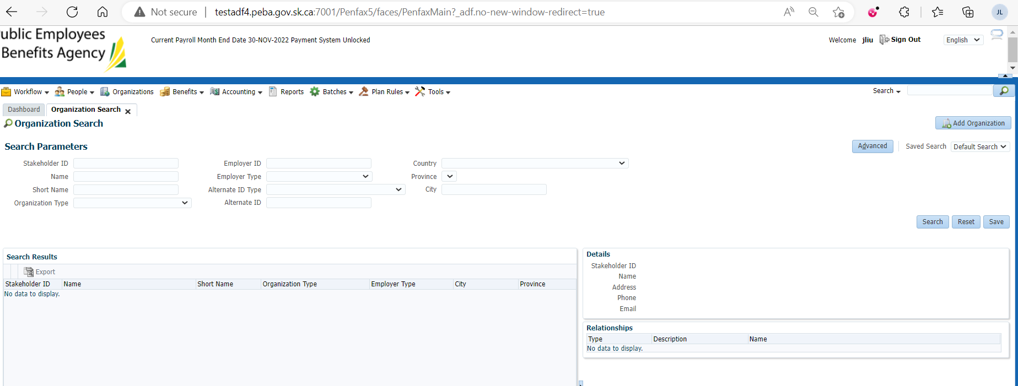

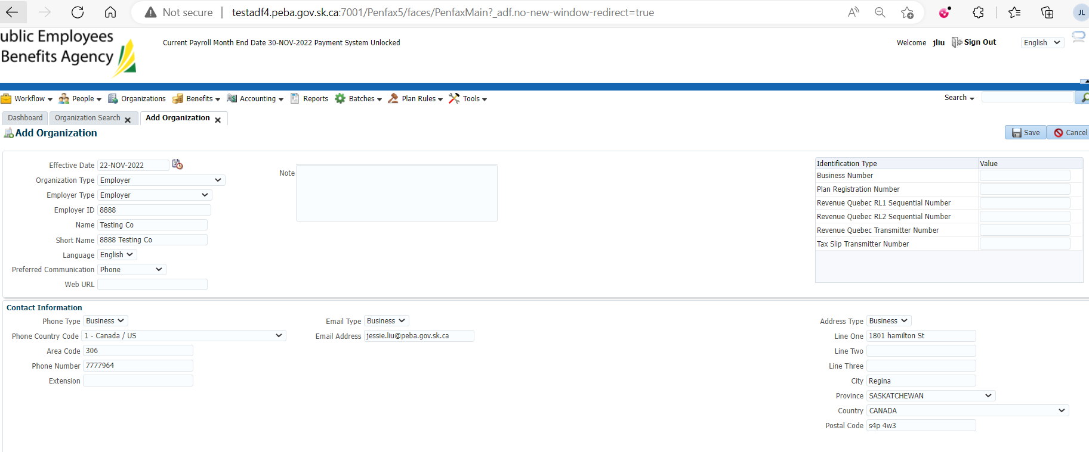

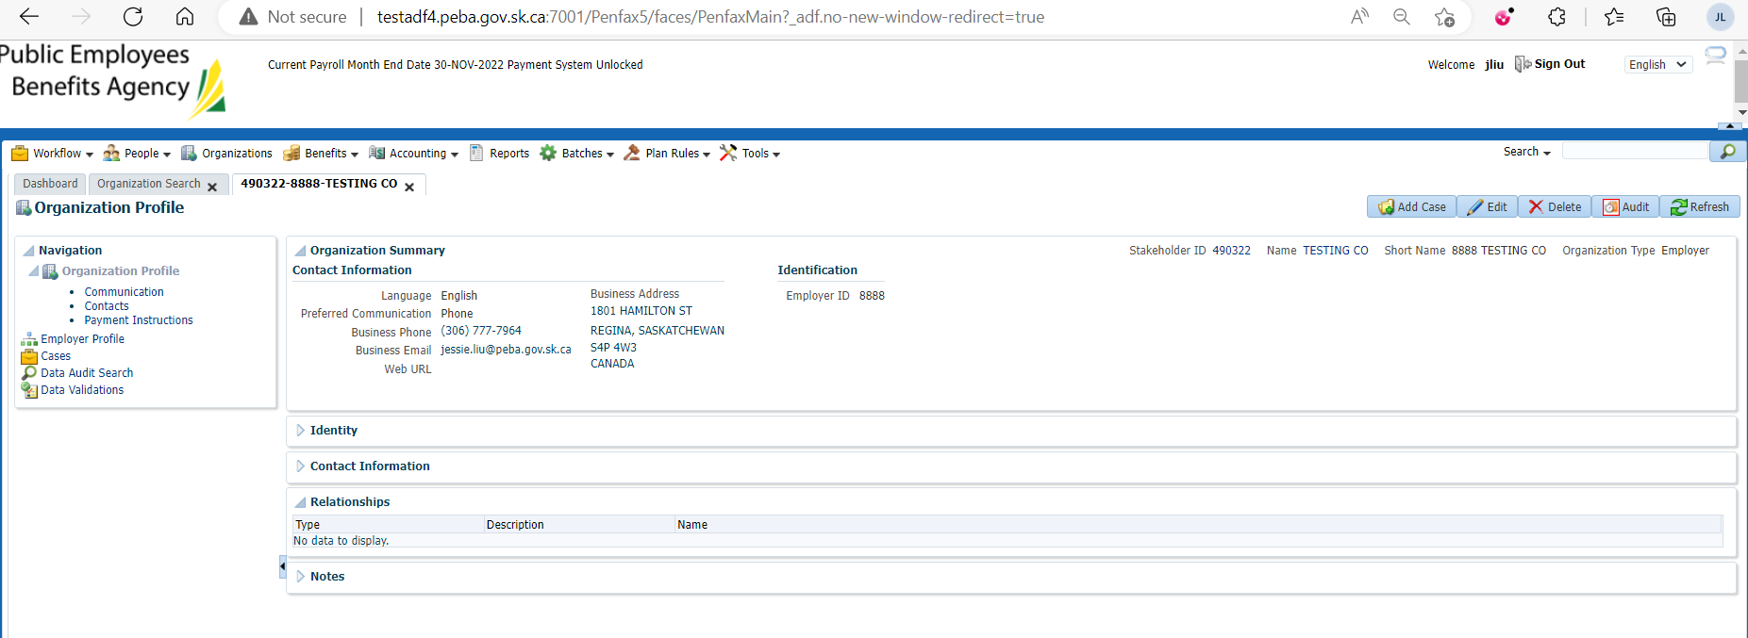

1. Add correspondence

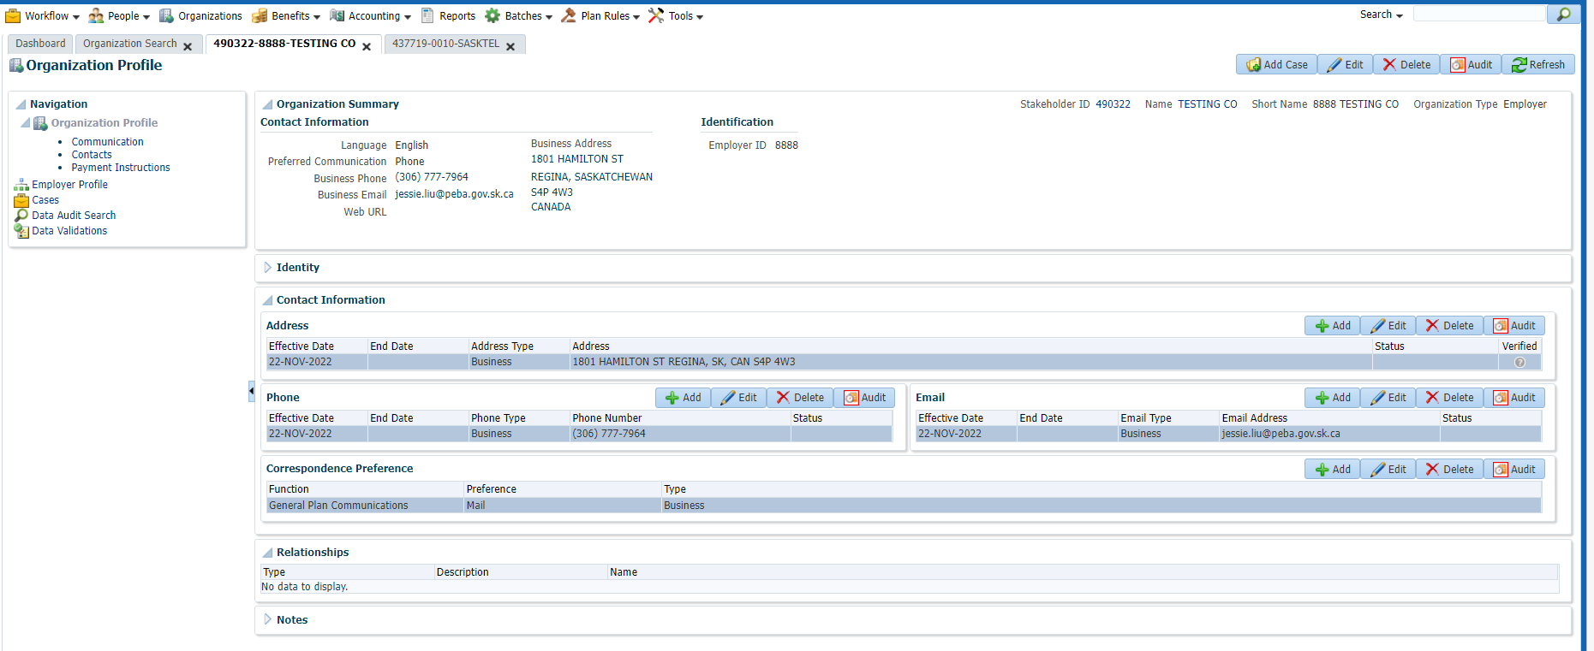

1. Add Contacts

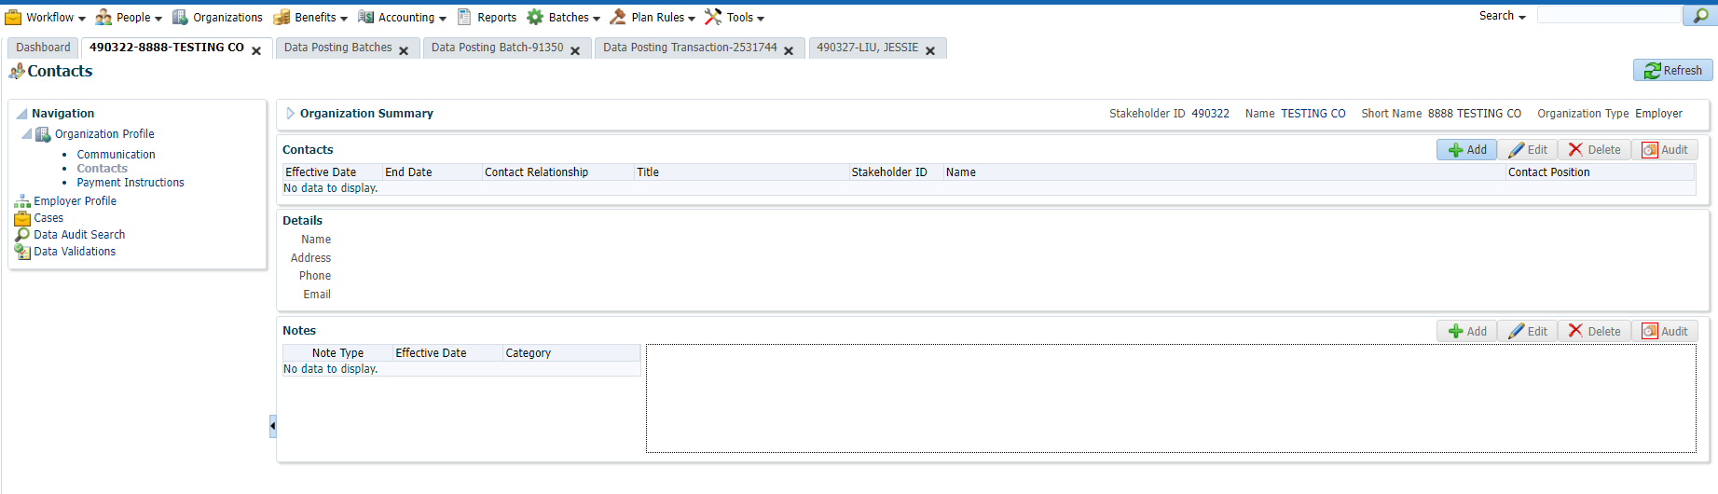

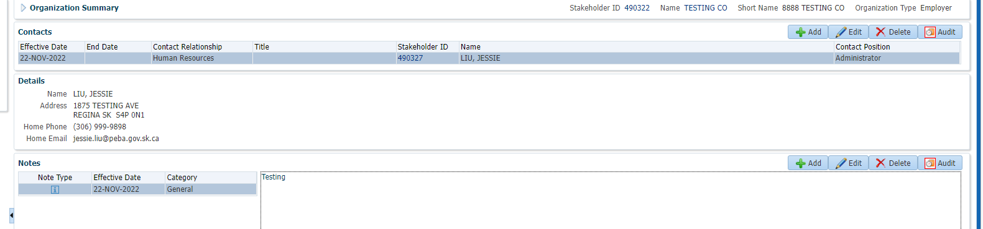

1. Add details for employer profile

